BRIEF BIO-DATA:

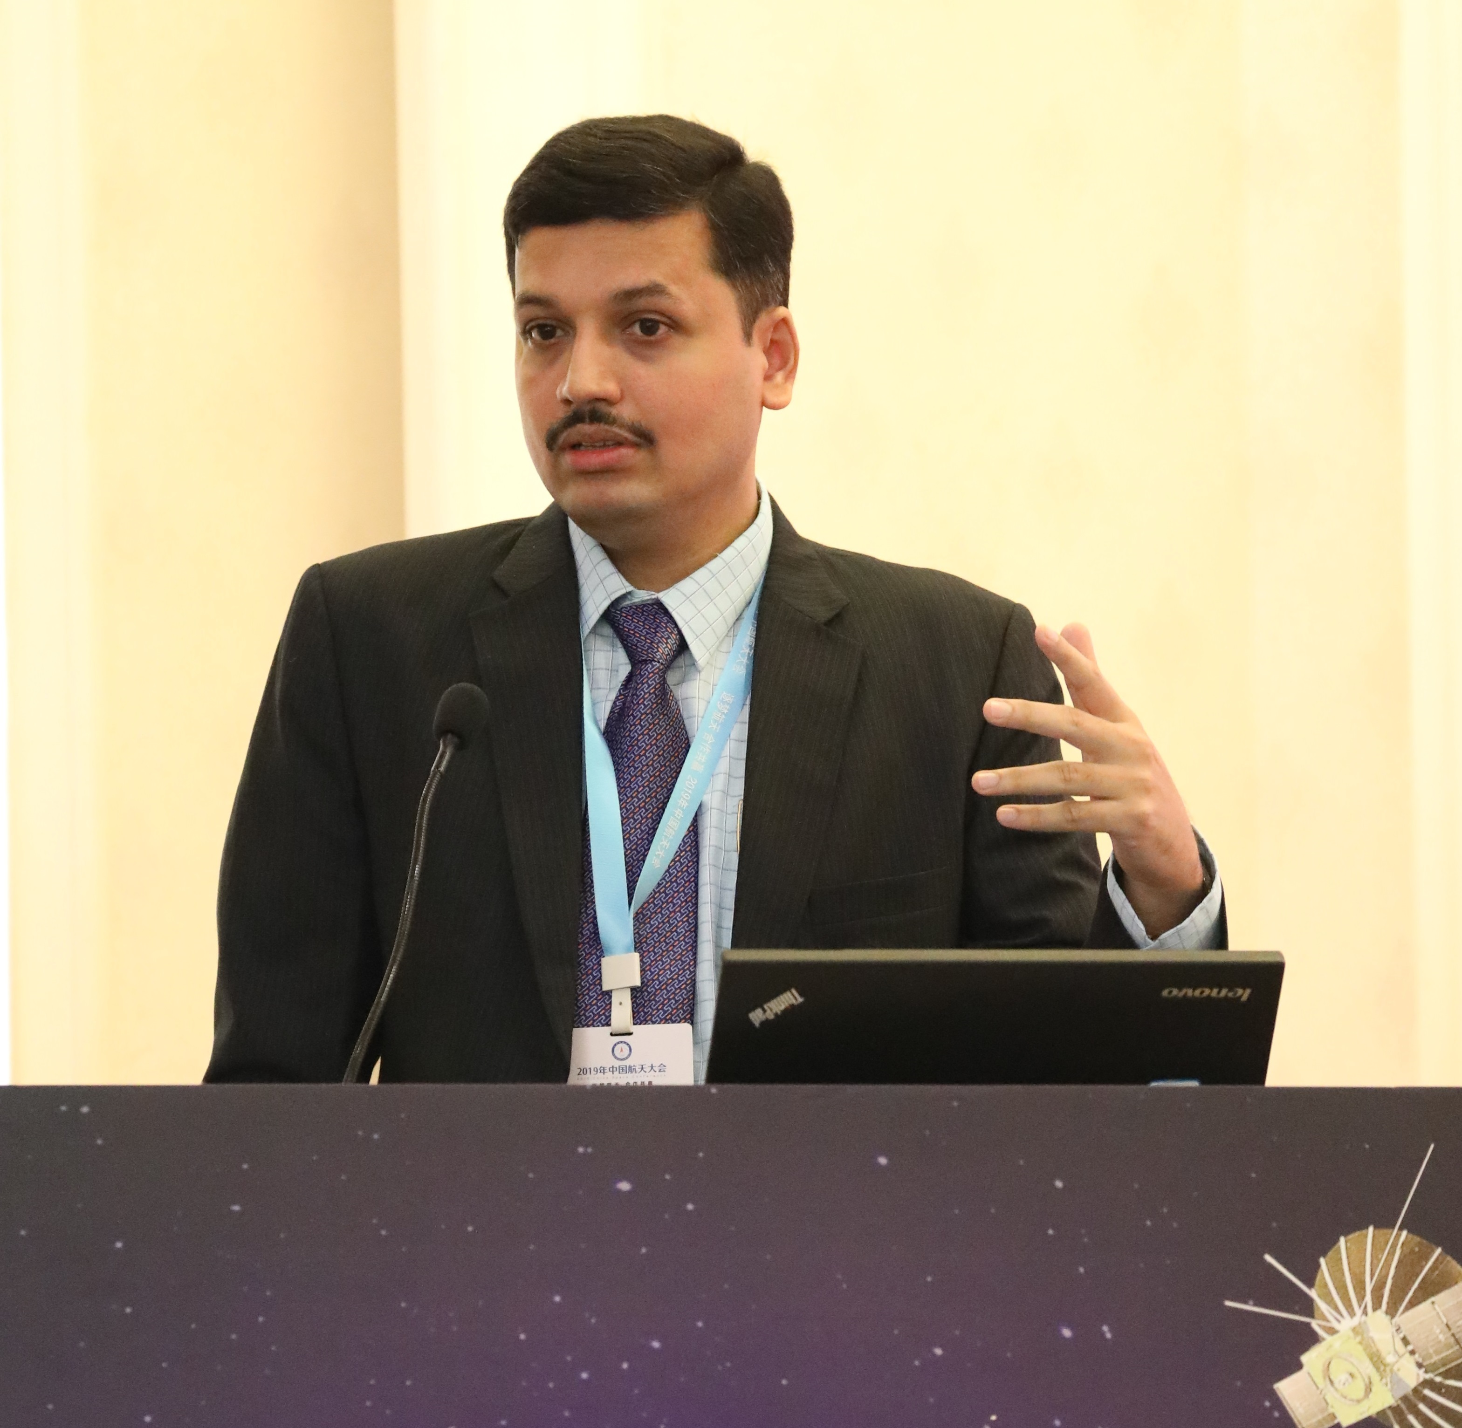

Prof. (Dr.) Sandeepa Bhat B.

Prof. (Dr.) Sandeepa Bhat is working as a Professor of Law and Director of Centre for Aviation and Space Laws at National University of Juridical Sciences (NUJS), Kolkata. He has over twenty years of teaching and research experience at National Law School of India University (NLSIU), Bangalore and NUJS, Kolkata, which rank as top law schools in India. He has done his specialization in International Law and Business and Trade Law (LL.M.) with First Rank and double gold medal at University of Mysore. He had also secured Third Rank at Mangalore University during his LL.B. and top scored his college to receive the gold medal. His Ph.D. is in the field of Space Law.
Dr. Bhat has the experience of researching on five Major Research Projects sponsored by World Bank, Indian Space Research Organization, the WB Judicial Academy, Ministry of Justice and Ministry of Environment, Forest and Climate Change. He is currently working on Airport Governance project under the government sponsorship. Apart from being a member of Board of Advisors of Global Network against Weapons & Nuclear Power in Space, Brunswick, United States of America, he has the distinction of being the member of the American Society of International Law, Baltimore, USA, International Academy of Space Law, Moscow, Russia, and the International Institute of Space Law, Paris, France. He holds the unique feet of being the first Indian to be inducted as the UNIDROIT Correspondent for India in nearly 100 years’ of UNIDROIT’s existence as an international body. Dr. Bhat is the founding Editor-in-Chief of the Asian Journal of Air and Space Law and Lex ad Coelum- a blog for discourse on aviation and space laws, and he is also associated with various other publications in different capacities.
Dr. Bhat has published four books on Space Law and four books on Medical Law. In addition, he has published more than fifty five articles in the journals of international and national repute, which include Journal of Space Law, Annals of Air & Space Law, New Space, Proceedings of Colloquium on Law of Outer Space, Asia Pacific Journal of Health Law & Ethics, Sri Lanka Journal of International Law, Latin American Journal of Aeronautical Law, Athens Journal of Law, Kathmandu School of Law Review, BiLD Law Journal and Asian Journal of Air and Space Law. He is the recipient of the inaugural Sachdeva Award for Space Law 2022 in recognition of his outstanding authorship in space law. He has presented over hundred and fifty research papers in the international and national conferences including the coveted International Astronautical Congress, as well as in international conferences held at Jakarta, Seoul, Sharjah, Singapore, Changsha, Paris, Austin, Southampton, Cambridge and Istanbul. He also has the distinction of being the member of Indian Space Research Organization’s Expert Group for drafting the National Space Act for India. His major areas of teaching, research and publications are Air & Space Laws, WTO Law, Medical Law and Nuclear Law.

